E. St. Joseph’s Cemetery - A “Horrible Haunting”

What is “worse” than the “dead” haunting the “living”? It is those “living” who haunt the “dead”! There is no more isolated space, nor more cultural loss of identity and individuality, no more absence of “ethnic pride”, than an abandoned cemetery, peopled by one cultural tradition, especially one that is located along a well travelled route. This is one place that is “prime real estate” for a “haunting” to occur! One such place is the old St. Joseph’s Lithuanian cemetery, located alongside the road between Mahanoy City and Brandonville, Schuylkill County, Pennsylvania.

Photo 25: St. Joseph’s Cemetery
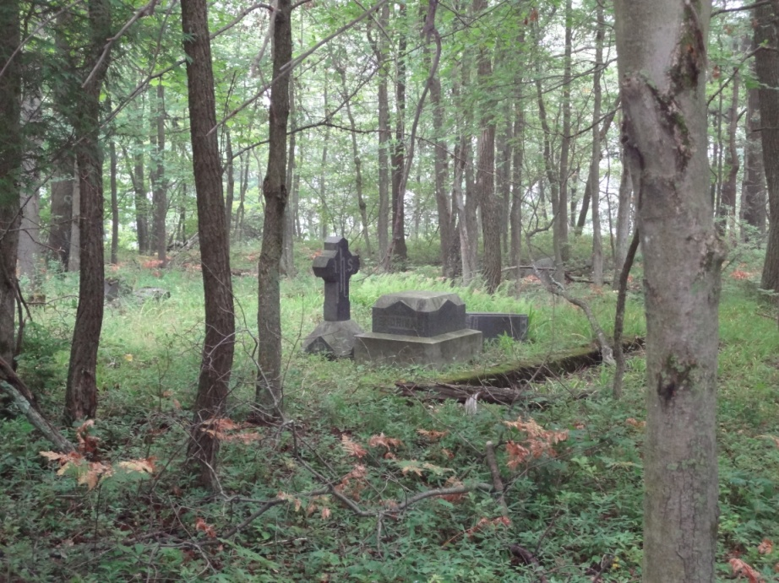

Though there is a “new” St. Joseph’s Cemetery, located on the opposite mountainside of the town of Mahanoy City, it is still a sad state that these particular “remains” are lost to contemporary residents of the area. Joseph’s Catholic Church in town is the only remaining Catholic Church that has an “active” congregation. Do the dead at old St. Joseph’s Cemetery appreciate this irony?

As an anthropologist, I feel very emotional about this loss of cultural identity. As an archaeologist, I see the ruined cemetery (overgrown with weeds, trees, and toppled memorials) for what it is: a place abandoned and out of place with contemporary concern and interest. As an actor, I can sense the stories (albeit “ghost stories”) that can be told in and about this place, and what happened to it!

I had written a series of articles, dispersed throughout my books, about St. Joseph’s Cemetery. I hope by talking about it, I may “resurrect” the “living”, rather than the dead, to the lost heritage that is contained within the crumbling walls, and unlocked gate. With these articles (and stories), I hope to end the haunting there, which is a “horrible” example of ethnic and human indifference!

As I enter the abandoned St. Joseph’s Cemetery, the atmosphere is “prison-like”, fortified by a sense of absence. It is a silent experience. The “outside” world is barred entrance here, though this is voluntary. The gate is always open, and there are holes in the wall facing the road. Activity, even natural acts of flora and fauna, recede into the background. Is this a question of ecology, conservation, ethics, or economics? What grows and lives here is beyond human control. Should they be?

Who (or what) protects this invisible wall of absence? It seems that only the stillness stands guard over the few visible graves, as if collecting stories and experiences of the few who remain here, and the fewer still who venture here! In all the times that I have come (so close to the town and road) I have never seen a person or car in or near this forgotten place. And I have never sensed a “ghost” here! I walk amid the plots of remains, waiting in the hope that my visit will be recorded and etched onto the crumbling monuments to the dead.

I pause and wait, hoping to hear their stories: how did they meet their end? Where did they live? What was it like during the heyday of the “coal rush”? I listen and receive their silent reply. I always find myself saddened because I can read their names but I do not hear their voices. I remain still and stoic, wondering what impact they left on the lives of those that followed after them? Is the silence that echoes throughout this place the answer to that question?

Is the neglect I view all around me, a phantom measurement of their legacy? It is hard to view this abandonment with people living so near. I only hope that someday, someone whom I’ve never met in life might come by my own gravestone, and not forget me! If so, will they wonder about my life, and what kind of person I once was? As they view my grave, I hope they open wide their imagination with thoughts of things that were (and not lost), and conjure things that might have been! I hope that my final resting place will not be like this!

It is with such thoughts that I come here, not as frequently as I could (or should) to pay my personal respects. I visit this abandoned cemetery, though I do not have relatives here or owe an allegiance along ethnic lines. Nor do I visit this cemetery as an archaeologist, a seeker of truth. I come, not as one who knows about death, burials, ruins, and memory loss. I come here for the simple reason of being quite human and knowing how it is to feel lonely and abandoned by all.

I hope that those who are buried here have lost these human feelings, and are now happy and content. Reading the histories, I know that life during the “coal boom” was harsh, dangerous, and noisy. Maybe, that is why this cemetery, an ethnic one, though abandoned, is still so silent? Has this place, like it’s “inhabitants”, finally been laid to rest and are now at peace? This is one cemetery that is indeed “haunted”, but not by the “dead”! It is haunted by those who continue to live in Mahanoy City (and the surrounding area). The “living” here haunt the “dead” with their absence, not their presence!!

Photos 26 & 27: Two views of St. Joseph’s Cemetery
