A. Sleepy Hollow

This is a “ghost story” about Sunnyside, the legendary home of Washington Irving, the writer of the classic ghost story, “The Legend of Sleepy Hollow”. I have visited his home twice, both during the “Halloween” season. It was quite a haunting experience, but not for what you would imagine! Thought the house is said to be haunted by a number of ghosts, Irving concluded, “they” are not what “haunts” the home today. Let me tell you my “ghost story”.

Those who “worked” the legendary homestead, as hosts and tour guides, were 21st c. “robots”, unemotional puppets, with pre-programmed dialogue, and devoid of energy! Were they sleepwalking through their presentations, taking a cue from Irving’s, Rip Van Winkle?! They were little versed in the local lore of the place, but well-trained in “assembly-line” dynamics (move on….next group, please, efficiency)!

They answered little questioning, their feeble statements a concerted request to continue on to the next “robot station”. I twice asked about the ghosts here. It was as if I spoke a foreign language! Yet, Irving himself, talked about the ghost of a woman in an upstairs bedroom. The final constructed version of Sunnyside that was built from the bland historical fragments given by the guides was a sketch that was devoid of myth and mystery! There were no ghosts seen (or heard about) here, only the phantoms of poor “storytelling”! Sunnyside, during this festive season, was no “lasting” tribute to a renowned author of highly imaginative tales. No wonder Irving still haunts the place!

The town of Sleep Hollow itself is indeed asleep! There was little change here since I last visited the place four years ago. The place continues to be devoid of “ghost tourism” exploitation (a good thing!). Unlike Gettysburg, there are no overt merchandising of a town haunted by folklore and history. There are no ghost tours advertised in store fronts. There are no “ghost hunters” wandering the streets, fields, and woods. Some can be observed, though, in Sleepy Hollow Cemetery, and at the Headless Horseman Bridge, deeper in the woods.

At the “tourist” sites (Sunnyside, Philipsburg Manor, and the Old Dutch Church), there are no layered displays of the “Ghosts of Sleepy Hollow”. This phantom past is not present in Sleepy Hollow. Somehow, I miss this particular haunting! But, I am so happy that this place, at least on the surface, is no prime real estate for “ghost hunting!

“There is a magic to finding a place of legend, seemingly long lost. I sat in the silence for a long time, thinking of the legend, and wondering how a spot which was known….had managed to get itself lost”.

• Todd Atteberry, “The Pursuit of Ichabod Crane….”

This “lost” aspect has created the current “haunted” nature of the Sleepy Hollow landscape!

Photo 22: Sunnyside
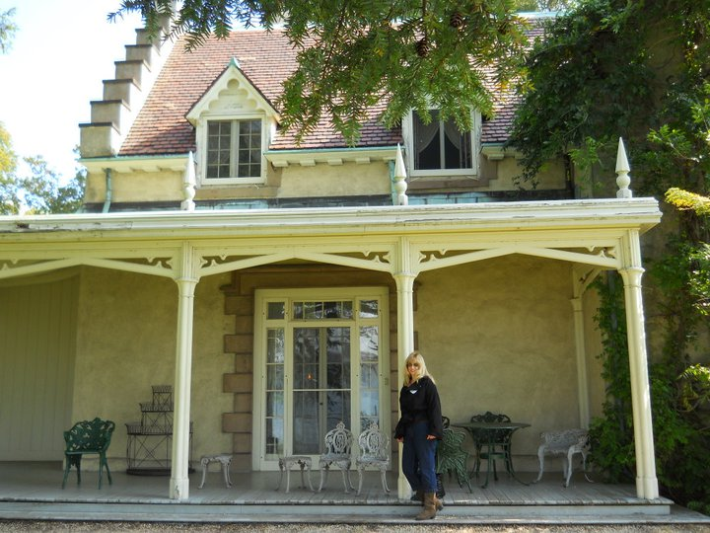

Photo 23: Sleepy Hollow
